YOUR GUIDE TO
Parentapps Connect

PARENTAPPS CONNECT
At Parentapps, we are passionate about helping schools improve communication with parents and our team are dedicated to building tools to do just that. With the help of amazing feedback from our schools, we are proud to have built a new and improved parent communication platform. Packed with useful features that provide answers to the challenges that schools face, we are thrilled to announce Parentapps Connect, the future of parental engagement.

Connect utilises ground-breaking technology that guarantees that your school or nursery will be able to communicate with 100% of your parents. Once registered, Connect provides full visibility of all your users which can also include additional family members.

We want to be there for you, whenever you need us. To begin with, we have created this simple to use instruction manual to help you get started with your new app. It contains everything you need to know to get up and running in no time, but if you still need help, just give us a call.

CONTENTS
PARENTAPPS CONNECT 2
SETTING UP YOUR PARENTAPPS CONNECT SYSTEM 5
HOW TO LOG IN TO YOUR PA CONNECT PORTAL 5
GETTING STARTED 6
HOW TO INVITE ADDITIONAL ADMINISTRATORS TO MANAGE THE PORTAL 6
MIS INTEGRATION – HOW TO IMPORT CHILDREN & PARENTS USING WONDE 6
HOW TO IMPORT CHILDREN & PARENTS MANUALLY 7
HOW TO MANUALLY PROMOTE YOUR CHILDREN 8
HOW TO ADD STUDENTS VIA A CSV FILE 10
ADDING ADDITIONAL CONTACTS MANUALLY 11
HOW TO CREATE CATEGORIES FOR CONTENT 12
SENDING INVITATIONS 13
HOW TO PREPARE FOR THE LAUNCH OF YOUR APP 14
HOW TO INVITE YOUR PARENTS 14
HOW TO ENGAGE YOUR INACTIVE USERS 15
CONTENT 16
CONTENT OVERVIEW 17
HOW TO UPDATE TERM DATES 17
HOW TO ADD SCHOOL EVENTS 18
ARCHIVED EVENTS 20
HOW TO UPLOAD PDF DOCUMENTS 20
HOW TO ADD USEFUL WEBSITE LINKS 21
HOW TO UPDATE YOUR WEBSITE & SOCIAL MEDIA WEB LINKS 22
HOW TO ADD PHOTOGRAPHS TO YOUR GALLERY 22
HOW TO USE YOUR SPARE PDF AND WEB LINK TABS 23
ABSENCE & STANDARD CONSENT FORMS 23
CREATING YOUR OWN CUSTOM FORMS 24
EXPORTING FORM DATA 26
SENDING MESSAGES 27
HOW TO SEND A MESSAGE TO YOUR USERS 28
MESSAGE HISTORY & DELIVERY REPORTS 31
MANAGING YOUR APP 32
HOW TO CREATE USER GROUPS 33
REMOVING & DEACTIVATING USERS 34
MANAGING UPDATED CONTACT DETAILS 34
APPROVING ADDITIONAL CONTACTS 34
ALERTS 35
SUPPORT HUB 35
SUPPORT 36

PART ONE

SETTING UP YOUR PARENTAPPS CONNECT SYSTEM

HOW TO LOG IN TO YOUR PA CONNECT PORTAL
To log in to the management portal, use the link given to you during your very first training session and bookmark this for future reference. You will also need the password you created when setting up your own account through the invitation e-mail. Please make sure you also save this.

Please contact the office if you are having difficulties logging in.

IMPORTANT: Please make sure you are using Google Chrome as your internet browser.

Your dashboard is the first screen you will see within the portal. Here, you can quickly track your active, pending and inactive users. There is an active student counter in the top-right corner that will show you the number of students who have one or more registered users against them. This information will allow you to effectively target your inactive parents to get as close to 100% active students as possible.

There is also a recent staff activity tracker on the right-hand side so you can monitor when your users log in, send messages, create forms and events etc.

All portal menu options can be found down the left-hand side.

GETTING STARTED
There is a three-step process to set up your portal and add your users.

HOW TO INVITE ADDITIONAL ADMINISTRATORS TO MANAGE THE PORTAL
You will have been set up as a Super Admin user during your initial training session. You can now manage and add additional users to the portal by selecting Settings from the menu bar on the left and then Admin Users. By selecting Create New, you will then need to enter the new admin user’s details. There are two options to choose from here. Super Admin gives the user full unfiltered access to the portal whereas Admin restricts the user to only see information related to the year and class which has been assigned to them.

There is also a toggle to allow users to receive parent notification updates. Toggle this on if you would like your admin user to also receive an e-mail whenever a parent updates their contact information within the app.

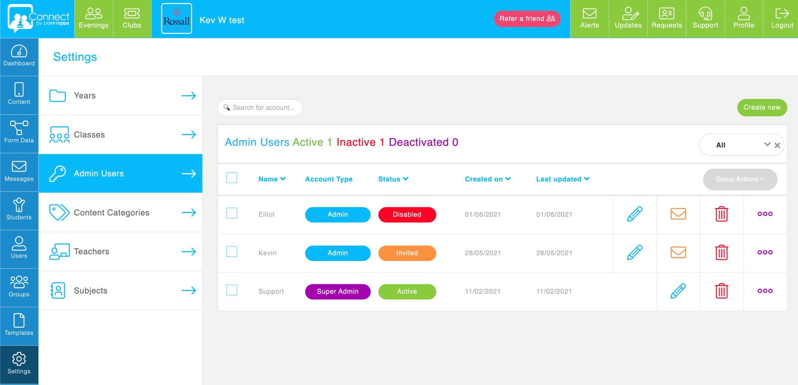

MIS INTEGRATION – HOW TO IMPORT CHILDREN & PARENTS USING WONDE
If your Parentapps Connect Portal has been set up using WONDE integration, your MIS data will have already been imported into your system ahead of any training session. You can easily update this data whenever you have made any changes in your MIS system. You will need to ensure that your MIS system has properly synced and updated before pulling these changes through to our portal.

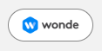
Within the Students section, you will see a white WONDE button in the top right corner. Click this button to begin the data refresh. You will be given the option to import any pre-admission students should you wish to. Any new students will then be displayed on the next screen. You must make sure to select which students you want to bring in before clicking Continue. This may take a few moments depending on the size of your school.

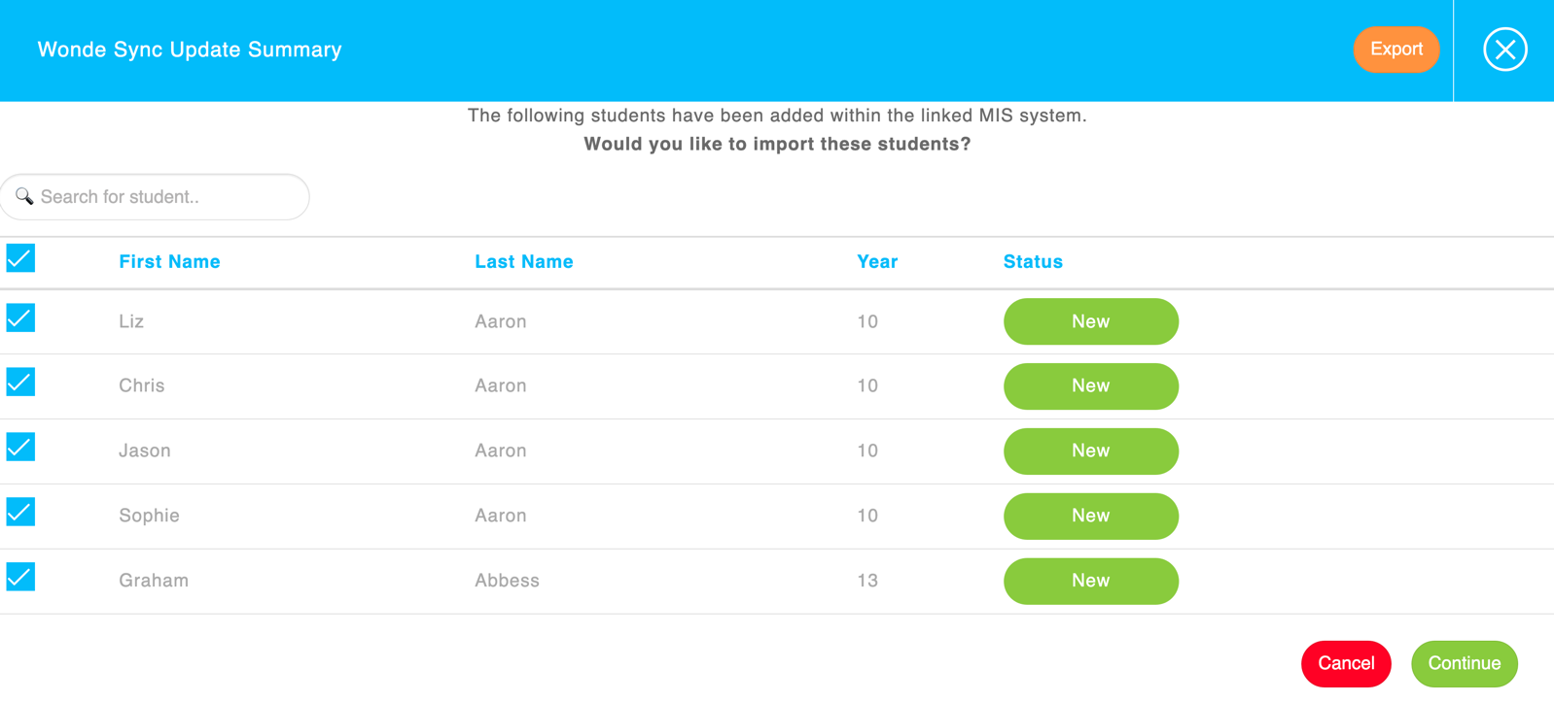
Once the WONDE refresh has completed, any new students that have been imported are now shown as inactive as they do not have any active users yet. By going into the Users section, you will be able to send these new users an invitation. By clicking on the blue edit pencil next to any entry, you can see the students details along with any users they are connected to.

If you change the priority of a contact with your MIS, this will not automatically update within the Parentapps portal. You must ensure to manually do this. WONDE will only import information for the current priority 1 contacts within your MIS.

Please note, any changes that you make within your MIS system will need to be left overnight before pressing WONDE to pull the new changes into the portal.

HOW TO IMPORT CHILDREN & PARENTS MANUALLY
If your Parentapps Connect Portal is not set up with MIS integration, there are two ways to add children into the system.

To add a student, you can do this manually by selecting Add Student under the Students section. Fill in the new record that opens by adding the new student’s details. You can also add siblings here by clicking Add Another Child. Further down, you can enter the details of the main user and add any additional contacts with their priority if needed before clicking save.

There will be an MIS ID field for both students and users. This is only for accounts set up using WONDE. Leave this blank if you are adding students manually.

HOW TO MANUALLY PROMOTE YOUR CHILDREN

Please note, this process will only need to be followed if you are a manual school. If you have WONDE integrated into your portal, please promote the children within your MIS system and press WONDE the following day.
Promoting your children can be done on an individual basis or in bulk, for example, moving all of your Year 5’s into Year 6. To manually promote your children, you will need to press the Promote button located under the Student’s tab of your portal.
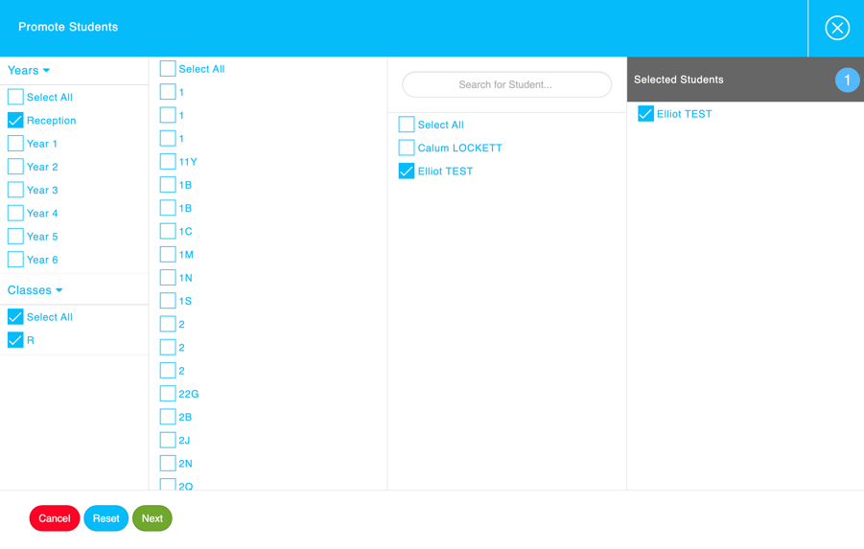

The system will require you to manually select from the Years and Classes drop down list which children you would like to promote. Once selected, press Next.

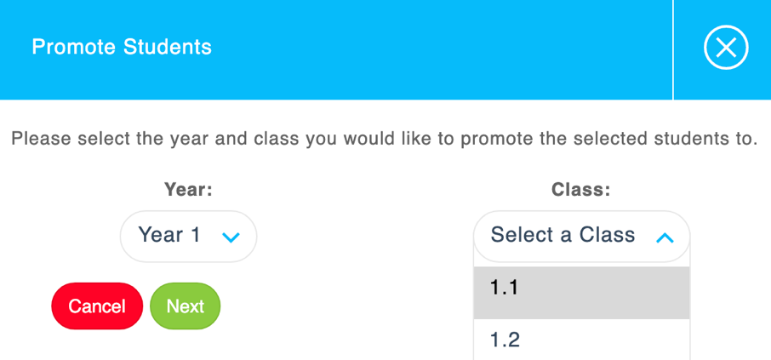

The system will then require you to choose which Year and Class you would like to promote the children into. Once selected, press Next.

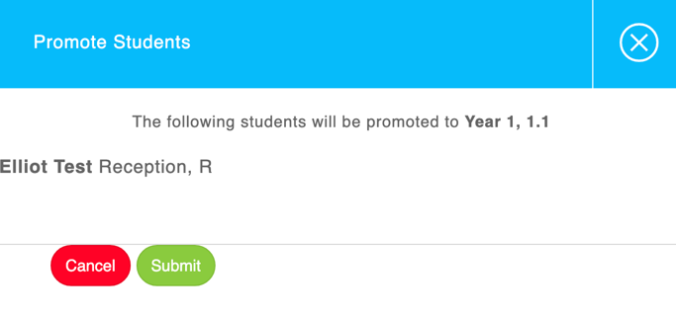
Finally, the system will give you an overview of which children have been selected to be promoted into a different Year and Class. Once the submit button has been selected, the system will apply the changes.

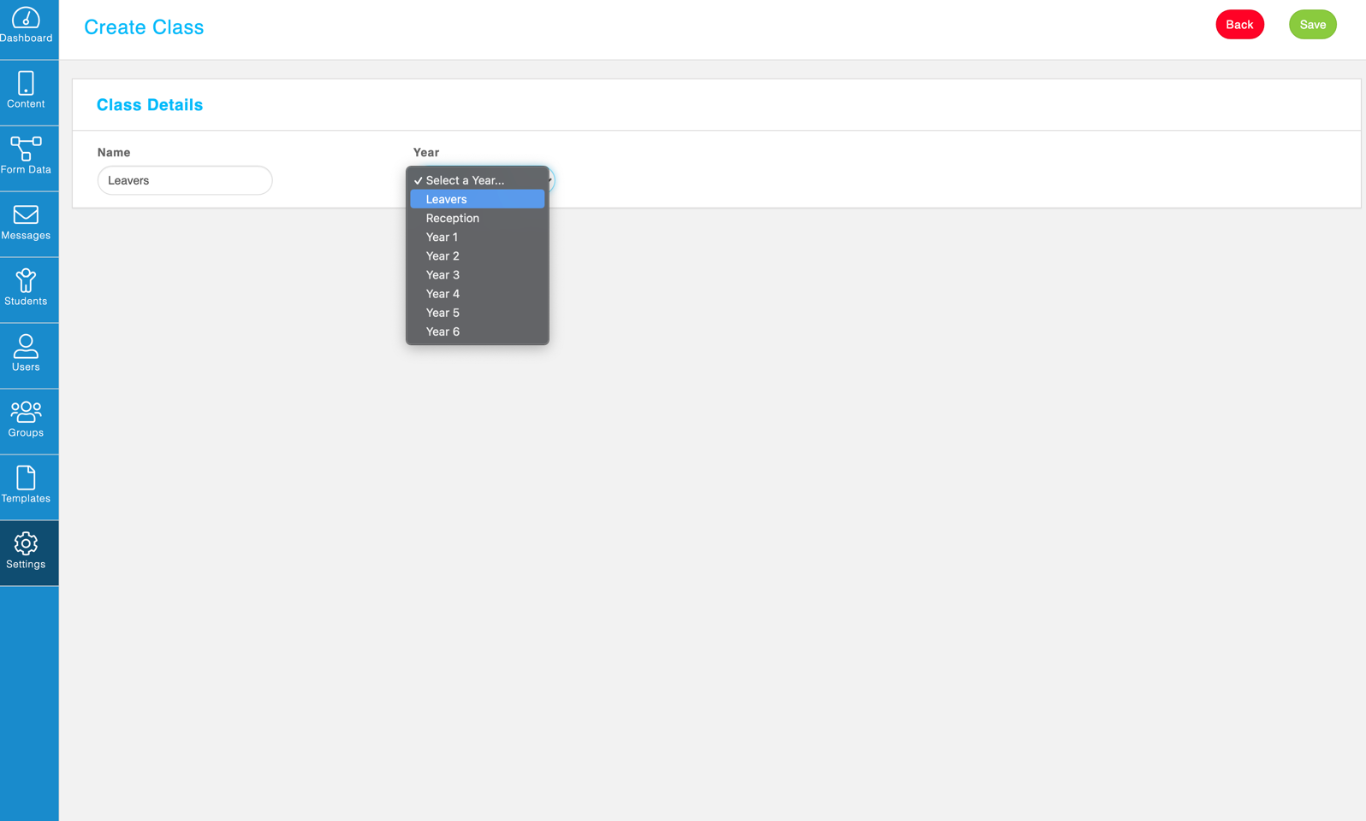
We would recommend making a Year and Class called Leavers for any children that no longer attend school. To do this, head into Settings on the left-hand side of your portal and create these filters. This will allow you to promote the old Year 6 children into this filter and bulk delete them out of the portal when you are ready to remove them.

HOW TO ADD STUDENTS VIA A CSV FILE
The second option is to create a CSV file to add multiple students and users.

A CSV is a file format used to store data which you can open using Microsoft Excel. You will need the recommended template for you to enter your data. Please contact Support if you require a copy of this CSV template.

The CSV template will contain set headings and example data to show you exactly how your information should look.

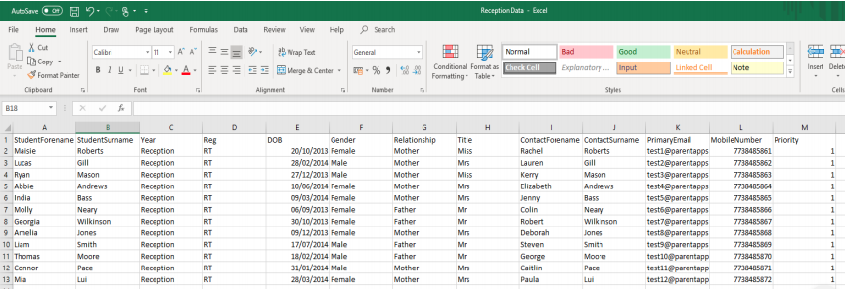
- Student Forename
- Student Surname
- Year/Age
- Reg/Room
- DOB – The format must be DD/MM/YYYY e.g. 20/06/2009
- Gender
- Relationship – The contact’s relationship to the child e.g. Mother, Father etc
- Title
- Contact Forename
- Contact Surname
- Primary E-mail – E-mail invites will be sent to new users for free
- Mobile Number – Mobile invites will cost one SMS credit
- Priority – Priority 1 will be the main contact for that student

You can add more than one contact per child, for example both parents. To do this, the parents need to be on consecutive lines on the CSV, the student’s details repeated and the priorities different for both contacts. The e-mail addresses must also be different for both contacts.

Once you have added all the entries to your CSV, save your file. You are now ready to import your data. Select the orange Import button from the top right corner of the student’s page before choosing the completed CSV file from your documents.

Once all of your data has been successfully imported into the portal, you will see a success message confirming this.

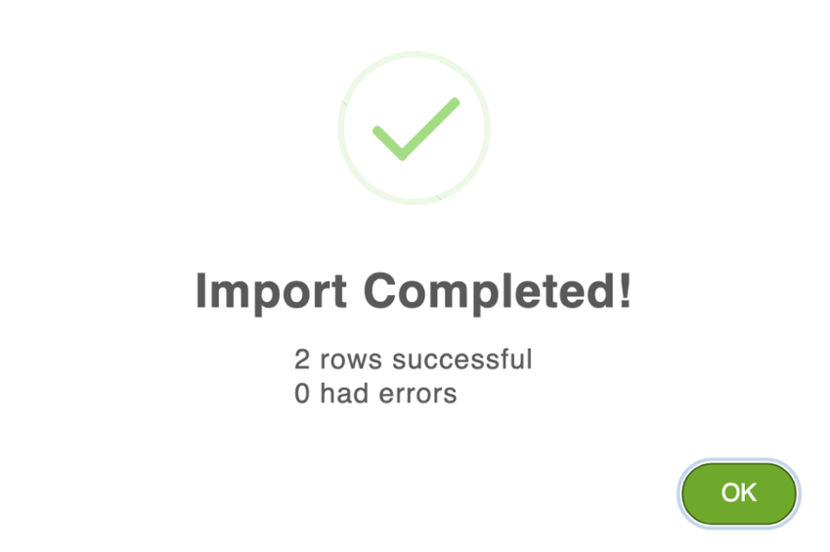

ADDING ADDITIONAL CONTACTS MANUALLY
If your system is linked to your MIS system through WONDE, it will only ever pull through the priority 1 contact for each child.

We understand that some schools and settings need to have more than one contact per child so there are two ways to add additional contacts in.

The first is via the user. Within the app, the user will see a button called Additional Contacts. Here they can suggest up to 3 other contacts who may need access to the app. This will then be reviewed by the Super Admin users before the requested invitation is sent out. Once the additional contact is either approved or declined, the original parent will receive a notification confirming the status.
The second method is to manually add additional contacts to the student. To do this, you must click the blue edit pencil in the Students section next to their name.
You will then see space to add up to 3 additional users. Once you have filled in their details, you must then send their invitations via the user’s section.

HOW TO CREATE CATEGORIES FOR CONTENT
Creating categories is a great way of organising your PDF’s and web links when adding them into the portal. Click Settings, then Content Categories and click Create New. You should then add the title of your category and click Save.

Now, when you upload any PDF document or website link, you can also assign them to one of your custom categories. These will appear as sub-headings on the user’s phone making it easier for them to sort through the information.

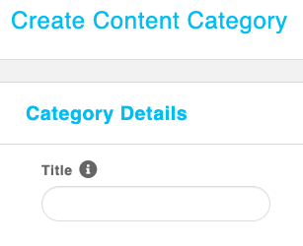

PART TWO

SENDING INVITATIONS

HOW TO PREPARE FOR THE LAUNCH OF YOUR APP
To help you prepare for the launch of your app, we have a selection of materials that you can use to send to users. We have a launch letter, a flyer and some step-by-step instructions explaining how parents can activate their account. We also have a presentation that you can use during your welcome meeting for new parents. We would suggest you send out this information before your launch so your parents will be expecting their invitation.
You will also need to check through the content of your app to ensure that all of the information is accurate and up to date. Check that your term dates are correct including the start and end times of the school day. Add any upcoming events, newsletters, meals menus, policies and create any consent forms that you may need to use throughout the year.

HOW TO INVITE YOUR PARENTS
Once your app is ready and contains all the latest information, it is time to send your invitations. Within the Users section, you will notice that all your users will show as red and inactive.
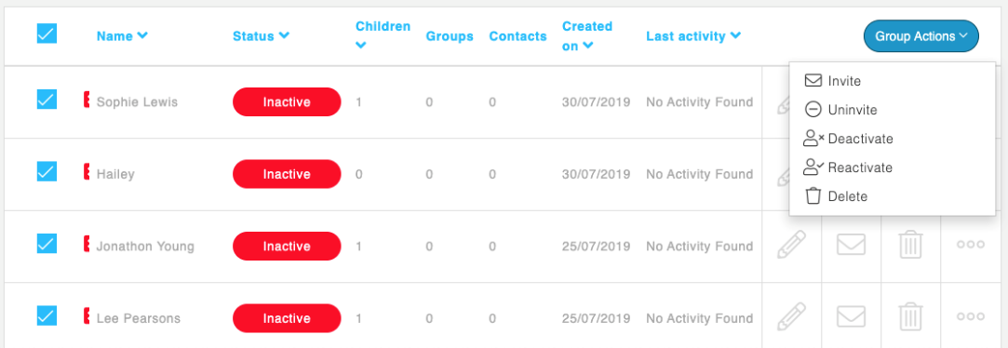
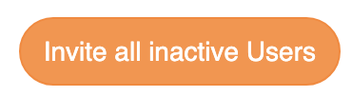
To send your invitations, you can either click the Invite All Inactive Users button in the top-right corner or you can select your users and click the Group Actions drop-down list and click Invite.

You will be presented with two options. System Determined and Send as SMS. System determined will automatically send the invitation via e-mail if an e-mail address is present or via SMS if an e-mail address is not present. The Send as SMS function will send all invitations via SMS regardless of if an e-mail address is present.
Once you press invite, it may take a couple minutes to send, depending on the number of students at your setting. Once completed, you will get a success message and all user statuses will now show as orange and invited. Once the user has accepted the invite, their status will show as green and active.
From experience, schools have a much higher activation rate if the invitation is sent via SMS. To discuss adding a bundle onto your account, please contact our support team who will be happy to help.

HOW TO ENGAGE YOUR INACTIVE USERS
At Parentapps, we want to help you achieve as close to 100% activation rate with your users. This will not only save the school money but will also allow you to communicate and engage with users a lot more effectively. We have a dedicated Customer Service and Support team who can provide guidance and advice to ensure as many users as possible are using the app successfully.
The best way to engage your inactive users is by continuously promoting your app and highlighting the importance of receiving information about their children.
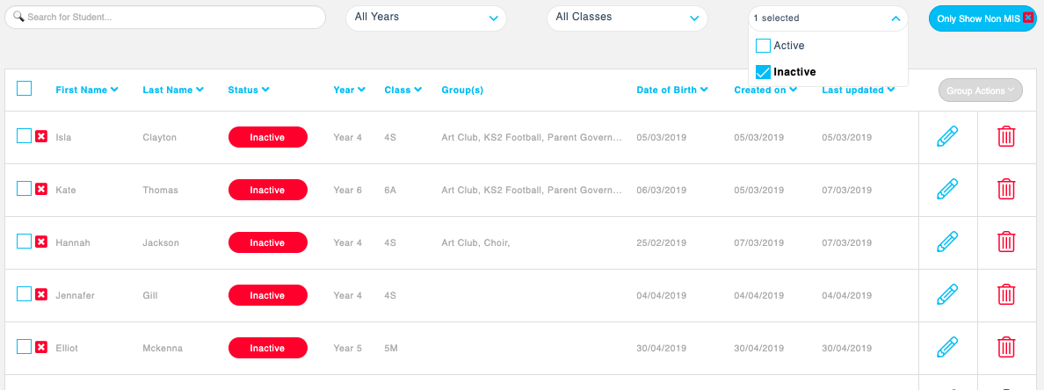
To engage inactive users, you will first need to identify who your inactive users are. You can do this by going to the Users section from the menu bar and select the status as inactive from the drop-down list. All the users that now show are red. You can export these by selecting the blue export button in the top right corner. This will download a CSV of the users you need to target.

We recommend that if you’re having difficulties getting users to activate with an e-mail address to re-send their invitations via SMS.
We also suggest that you send an e-mail or SMS to your inactive users, explaining that you have noticed they haven’t yet activated their account and you will be sending them a new invitation at a particular date and time. This will get their attention and pre-warn parents to expect a new invitation.
Finally, it is important to remember that the more you use the app, the more your parents will interact and tell other parents about it. This will prompt inactive parents to download the app and register their account.
If you have any parents that are struggling to download the app or having any other issues, they can also contact our support team directly either via phone, e-mail or the live chat on our website.

PART THREE

CONTENT

CONTENT OVERVIEW
The Content section displays all the tabs within your app. There are five different types in total.

- Term Dates / Events – allows you to add key dates into the app for special or important events. Parents can then add these to their phone calendars by pressing the plus icon within the app.
- PDF Documents – you can attach PDF documents such as letters and newsletters and send these electronically to parents.
- Website Links – provides links to your own or third-party websites.
- Consent Forms / Surveys – you can build your own custom forms and surveys or use pre-made templates.
- Photo Gallery – allows you to upload images on the app. You can have up to 500 images in the app at any one time.
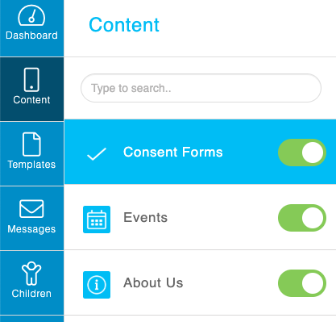
You can re-arrange any content tab within the portal by dragging and dropping the icons. This will re-order the tabs in your app. The top three tabs will appear on your app home screen alongside the messages tab.

You can also disable or enable tabs from the user’s phone by selecting or deselecting the green on/off toggle.

You must click save in the top right corner for any changes to take effect.

HOW TO UPDATE TERM DATES
To create a new term date, choose Create new. Add a title and description, if necessary, before entering the date and time details.
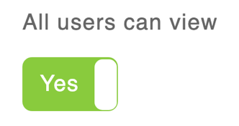
To make the term date available to everybody, toggle the All Users Can View button to Yes.

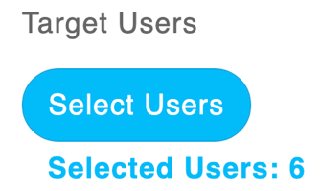
If you want to target specific users, click Select Users, select the students, then related users before clicking save to proceed.

Finally, you can also turn on the send notification toggle if you want users to receive an automated notification of the term date. If you would like to personalise the message, the Add Message feature allows you to type up to 2000 characters as well as using the #ParentName and #ChildName feature. By using the hashtag feature, the system will automatically pick up the person’s name and include it within the message.

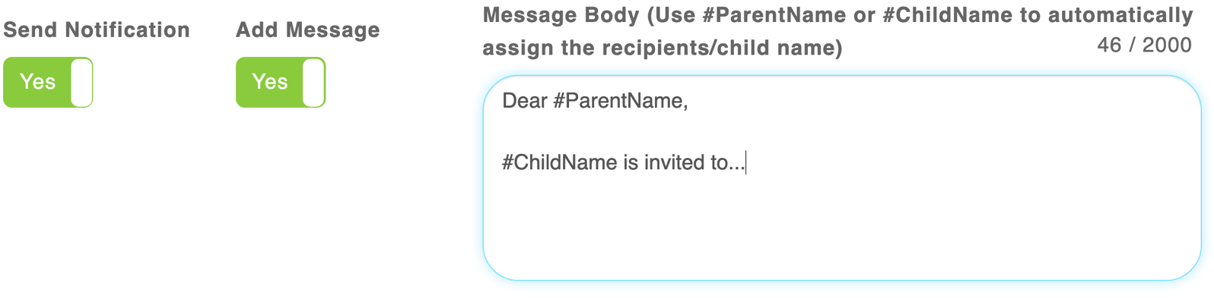

Users can then add this to their phone calendar by clicking the plus icon next to the term date within the app. You can edit any existing dates by clicking on the blue edit pencil next to the term date.

HOW TO ADD SCHOOL EVENTS
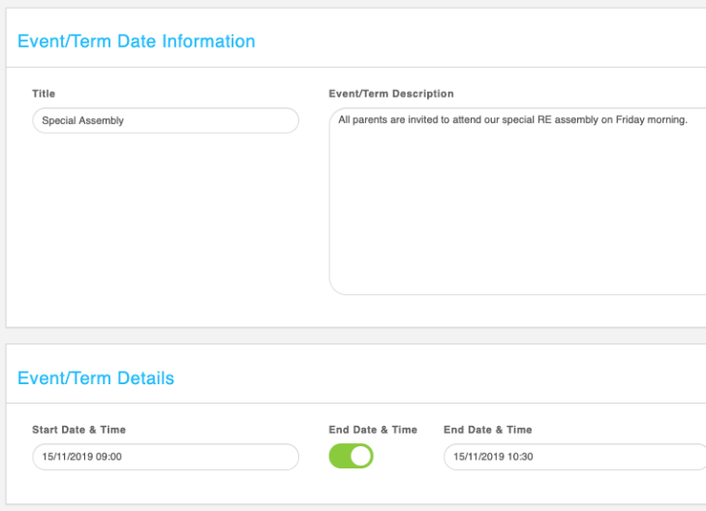
To create a new event, choose from either Create new or Create recurring.

Give your event a title and put any additional information in the description box.

Next, select the start date and time of your event and if necessary, you can add an end time. You can also add an event location should you wish to.

At the bottom, you will find the Preferences section. This is where you can target your users.
To make the event available to everybody, toggle the All Users Can View button to Yes.

If you want to target specific users, click Select Users, select the students, then related users before clicking save to proceed.

Finally, you can also turn on the send notification toggle if you want users to receive an automated notification of the event. If you would like to personalise the message, the Add Message feature allows you to type up to 2000 characters as well as using the #ParentName and #ChildName feature. By using the hashtag feature, the system will automatically pick up the person’s name and include it within the message.

Your new event is now live within the app. To add a recurring event such as a sports club or swimming lessons. Follow the same steps adding a title and description before choosing the frequency of the activity, then click save.

Please note that any names in red or amber won’t receive the notification or details of the event as they are either inactive or pending.

ARCHIVED EVENTS
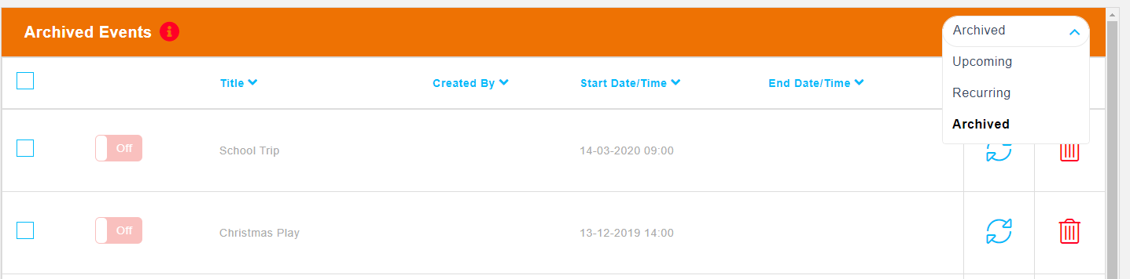
Once an event has passed, it will stay in the app for users to see for two weeks. Once this time has passed, the event will turn itself off and move into the Archived Section. Any past events will be displayed here, and you can view all the entries through the drop-down menu on the right.

If you would like to archive an event before the two-week time frame has passed, you can do this by clicking the orange archive button next to each entry or through the group action’s function.

From the archived event section, you can reuse events and put them back into the live event list within the app. By clicking the blue Reuse button, the event information screen will open. Here you can edit and amend the original times / details before clicking save to make live once again.

HOW TO UPLOAD PDF DOCUMENTS
There are a few PDF tabs within your portal. Examples of these may be Newsletters, Letters Home or Meals Menu.

To add a PDF, start by clicking Create new. Give it a title and icon should you wish to. There are two ways to upload – the first is to provide an external link. If your PDF is already on your website, copy and paste the URL link into this field. If not, click the PDF Upload toggle and upload a document from your computer.

Once you have uploaded your PDF, you can target your users in the preferences.
To make the PDF available to everybody, toggle the All Users Can View button to Yes.

If you want to target specific users, click Select Users, select the students, then related users before clicking save to proceed.

Finally, you can also turn on the send notification toggle if you want users to receive an automated notification of the PDF. If you would like to personalise the message, the Add Message feature allows you to type up to 2000 characters as well as using the #ParentName and #ChildName feature. By using the hashtag feature, the system will automatically pick up the person’s name and include it within the message.

REMINDER: Custom Categories for PDF’s can be created under Settings > Categories. You can assign your PDF’s to categories within the app.
Please note that any names in red or amber won’t receive the notification or details of the
event as they are either inactive or pending.

HOW TO ADD USEFUL WEBSITE LINKS
Within your app, you will see a tab titled Useful Links. This allows you to create a bank of additional content to send to your parents. To add a new web link, click Create new. Here, you can enter the title, URL and upload a thumbnail image should you wish to.
Once you have added your URL, you can target your users in the preferences.

To make the URL available to everybody, toggle the All Users Can View button to Yes.

If you want to target specific users, click Select Users, select the students, then related users before clicking save to proceed.

Finally, you can also turn on the send notification toggle if you want users to receive an automated notification of the URL. If you would like to personalise the message, the Add Message feature allows you to type up to 2000 characters as well as using the #ParentName and #ChildName feature. By using the hashtag feature, the system will automatically pick up the person’s name and include it within the message.

HOW TO UPDATE YOUR WEBSITE & SOCIAL MEDIA WEB LINKS
Most of your web links such as your website, latest news and social media pages are already set up for you within the app. Unless the URL changes, there is no need to update this. If you do need to change an existing link, click on the blue edit pencil to change the details before pressing save. To create a new link to a website, click Create New before entering the title and URL link in.

HOW TO ADD PHOTOGRAPHS TO YOUR GALLERY
Within the Gallery, you can add up to 500 images with your users. These can be added into a number of albums with different targeted users attached. To create a new gallery, click on Create new. Give your new album a title and then attach and upload any images by selecting the Add Image(s) button. The system will allow you to upload images in bulks of 20 and each image has a limit of 5MB for storage purposes.

Within the Preferences section, you can send to specific users.
To make the gallery available to everybody, toggle the All Users Can View button to Yes.

If you want to target specific users, click Select Users, select the students, then related users before clicking save to proceed.

Finally, you can also turn on the send notification toggle if you want users to receive an automated notification of the gallery. If you would like to personalise the message, the Add Message feature allows you to type up to 2000 characters as well as using the #ParentName and #ChildName feature. By using the hashtag feature, the system will automatically pick up the person’s name and include it within the message.

HOW TO USE YOUR SPARE PDF AND WEB LINK TABS
You can create new tabs and content using the spare PDF and weblinks within your app. If you do not have any or need any additional tabs, please contact the office where our support team will be happy to help you.

To activate a new tab, firstly give it a title and choose a suitable icon before saving. You can then add your new PDF or web link by clicking the Create new button and following through the steps.

For the tab to be visible to parents, you must make sure the toggle is switched to on/green. The same method applies to create a new web link tab.

ABSENCE & STANDARD CONSENT FORMS
There is a selection of forms already within the app such as report your child’s absence or medical appointment notification. You can easily edit these and amend the preferences to make sure the form is suitable for your school. To do this, click on the blue edit pencil next to a form.

The first screen you will see are the Preferences – title, description and target users etc. You can also add up to 3 notify e-mail addresses for different members of staff because once a user submits a response, as well as being stored within the system, the member of staff will also receive an e-mail to notify them of this.

By clicking the middle Content option, you will see how your form is made up and will look on the parent’s phone screen. Again, by clicking on the blue pencil next to each element, you can edit the titles and change options. You can also delete and replace with a field of your own to suit the needs of your school.

By clicking save in the top right corner, the changes will show within the app.

CREATING YOUR OWN CUSTOM FORMS
The Consent Forms tab can be used to build a variety of forms/surveys for your users to submit. Forms via the app can be used for many things such as parent’s permission, surveys, bookings etc.

Having your forms built into your app will provide a simple to use option for parents to submit certain information. It will also reduce printing and distribution costs and save a considerable amount of time for both the school and parents.

We recommend building your form within the Templates section. This is so you can reuse the form if required.

By selecting the green Create New Template button in the Templates section, you can begin to build your form preferences here by giving it a title and description. The description can hold a maximum of 2000 characters.

Next, click on Content – this is where you will build your form. The right side of the screen is how the form will look within the app.

Click Add New Item to start building the form. Each item has a different function. You need to select the function first before editing.

Name, Address, Phone Field and Email Field: requires the user to add in personal information for themselves or their children.

Text Field and Text Area / Paragraph: gives the user space to freely type. For example, please state any allergies or medical conditions. The text field can hold a maximum of 190 characters whereas the paragraph field has no character limit.

Multiple Choice, Dropdown List/Select or Checkboxes: allows the user to select options from a list or menu.

Image Upload: this will allow the user to upload a photo/image with their form, for example, attaching a doctor’s note.

Signature: makes any consent form a legal document by asking the user to sign on their device screen before submitting.
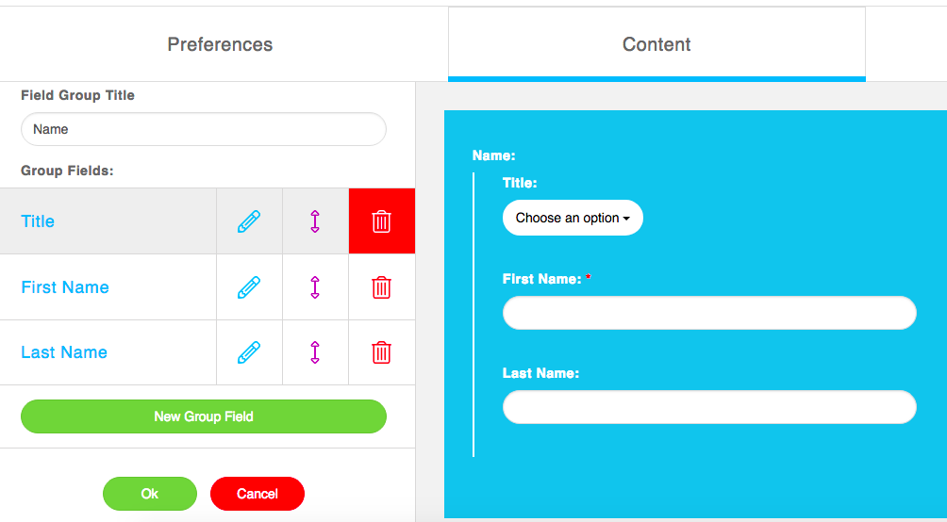
Once you have selected your option, you can edit and change the name or content of the field here. By clicking on the blue pencil, you can edit it further and decide if it will be a mandatory field by checking the box.

You can reorder the fields by dragging and dropping the purple arrows.

Press the Save button once you are finished building your template and you can now add the form into your app.

To add the form into your app, select Content from the menu bar and choose the form tab you wish to load your form into. Click on Use Template. You will then be displayed with our Global templates by default. Global templates are pre-made forms which the Parentapps team have created for all schools to use. These can then be edited to suit your school’s needs. Custom templates are forms which you have built yourself. Click on Custom to locate your template.

Once you have selected your template, you can fill in your preferences. You can select start and end times when you want the form to go live within the app and then decide who you want to make the form available to.
To make the form available to everybody, toggle the All Users Can View button to Yes.

If you want to target specific users, click Select Users, select the students, then related users before clicking save to proceed.

Finally, you can also turn on the send notification toggle if you want users to receive an automated notification of the form. If you would like to personalise the message, the Add Message feature allows you to type up to 2000 characters as well as using the #ParentName and #ChildName feature. By using the hashtag feature, the system will automatically pick up the person’s name and include it within the message.

E-mail Notifications can also be sent to 3 e-mail addresses every time a form is submitted. This is useful for absence reporting and appointment requests to be sent straight to the school office as well as being stored within our portal.

Have a final check through the form content and make any changes if needed and once you are happy, press the green Save button.

EXPORTING FORM DATA
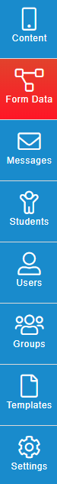
Any forms which a user has submitted via the app will be stored within the Form Data section. This will flash red to alert you to the fact you have a new entry. If your form has e-mail notifications turned on, then specific admin users will also be notified via e-mail.

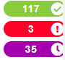
All your forms will appear on the left-hand side of the screen. You can see how many entries have been returned (green), how many new submissions (red) and how many outstanding forms (purple).

When looking at the new submissions, you can view an entry individually by clicking on the blue eye icon. You can also mark them as read and export entries as a PDF or CSV file on this screen.

Once a form expires, you should export and save the data on to your internal server and delete them from the portal. This will ensure optimum speed and performance and will minimise dated information being saved.

You can closely keep an eye on forms to still be submitted in the second tab. This will give you a list of users who need reminding about a form. You can click the Send Reminder to All button before choosing to send a system determined or a more personalised message.

PART FOUR

SENDING MESSAGES

HOW TO SEND A MESSAGE TO YOUR USERS
One of the main features of Parentapps Connect is the messaging option. Within this section, you can see your sent, scheduled and draft messages.

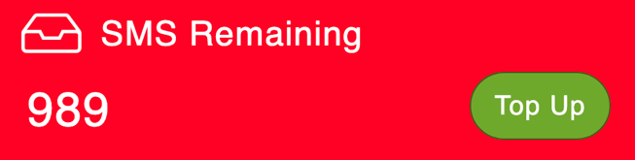
Your SMS remaining can be found on the main dashboard. Please keep an eye on this and if you need to order any more, you can click the green Top Up button.

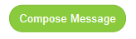
You can send three types of messages from our system – app notification, e-mail and SMS. To send a message, click on Messages in the menu, then click Compose Message in the top right corner.

The first section to fill in is the Message Content. Here, you can add a title and your message in the body. You have up to 2000 characters available here.
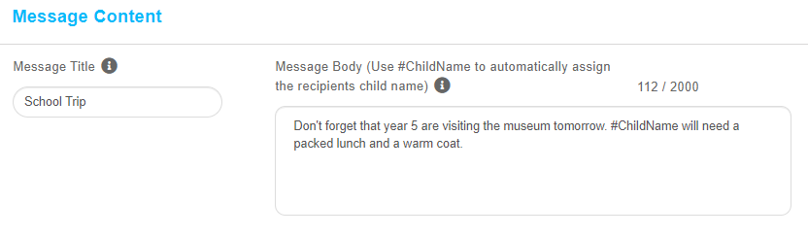
You can personalise your message to your users by using our #ChildName and #ParentName feature. This will ensure your users see their own name and their child/children’s name within the message.

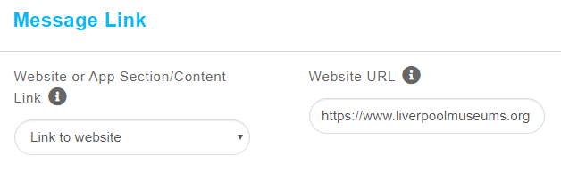
The Message Link option gives you the ability to send your users a specific link with your message. This could be to an external website. To do this, select Link to website from the drop-down and add the URL within the field. This section will only apply to active users on the app.
You can also link to a particular app section or content with your message, for example, a newsletter or term dates. This means when parents open the message, they can easily access that content by tapping on the Show Content button underneath the message and they’ll be taken straight to that part of the app.
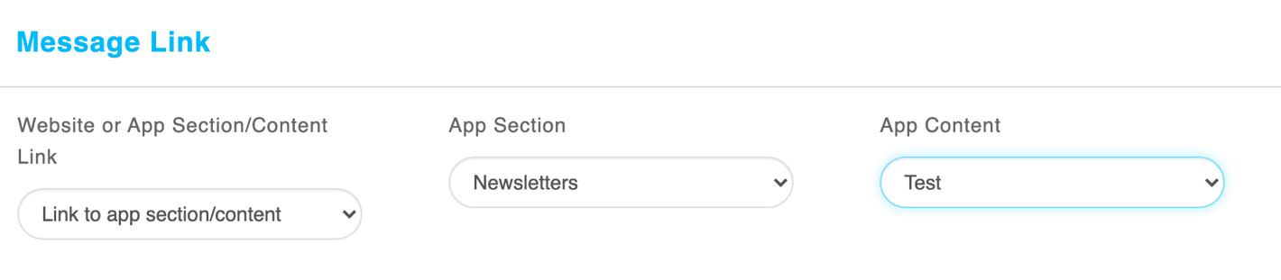

Message Preferences is where you decide who the message will be delivered to and how it is going to be sent.
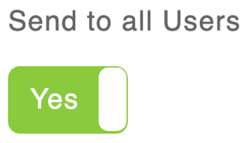
You can toggle on the Send to All Users button to send your message to all users within your system.

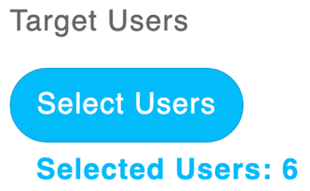
Alternatively, you can target specific users by clicking Select Users, select the students, then related users before clicking save to proceed.

After you have targeted your users, you can then select how the message will be sent.

App Notification – An app notification is a message that pops up on the user’s device when connected to the internet. These are free to use and can only be viewed by active users.

E-mail – An e-mail can also be sent for free to your users through the app. Please note, they will not be able to open any links or attachments. You can send as an e-mail or send as e-mail to inactive users only. This will allow you to communicate with all users 100% of the time and is particularly useful when first launching your app.

SMS – An SMS is a text message which can be sent to all users, or you can send an SMS to Inactive Users only.

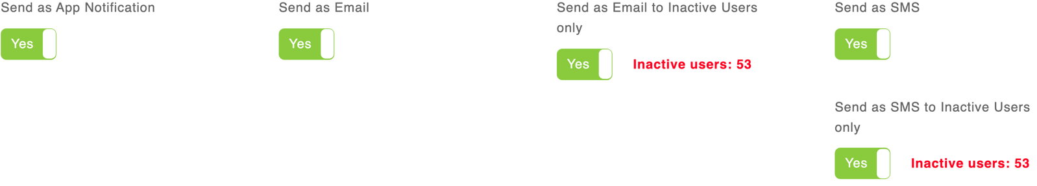

Please be aware that a SMS message is limited to 160 characters. If your message is more than this, it will use multiple SMS credits from your account.
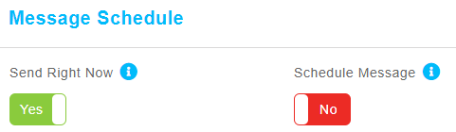
Then you can choose when to schedule the message. You can choose to send right now or to schedule a message for a later date and time using the appropriate toggles.

When you are ready, click send in the top right corner.

Finally, you have the option to store your message as a draft by clicking Save as Draft. This feature comes in handy when you want to store your progress with your message and come back to it at a later stage. The system will save it exactly how you left it so you can pick up from where you left off.

MESSAGE HISTORY & DELIVERY REPORTS
Within the sent section of your Messages, you can see a full history of everything which has been sent to your users. There is a search bar in the top left corner where you can search for messages, users or students.
You have full visibility and delivery reports alongside each message. By clicking on the icons, you can see the date and time a push notification has been read and can resend it to those users who haven’t yet read the message. You can see how many SMS messages have been delivered and undelivered and how many e-mails were sent.

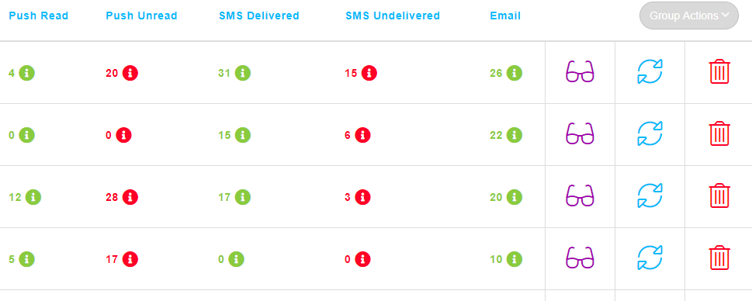
You can read what message has been sent by clicking on the purple glasses button. The blue reuse button allows you to reopen a message that was previously sent to parents exactly how it was composed to then send out again, this saves you from composing a message all the time. You can delete a message using the red delete icon which will also be removed from the parents’ message inbox on their app.

PART FIVE

MANAGING YOUR APP

HOW TO CREATE USER GROUPS
Groups are useful to create if you need to target a specific number of users regularly, for example, a football club or Governors. If your app is synced to your MIS through WONDE, all groups from your MIS System will also pull through. You cannot edit these in the Connect Portal, only through your MIS.

Click on Groups in the menu bar and click Create New. Give your group a name before selecting students / users to add into your group and click Save.

Once you have made your groups you can then target your parents with push notifications. instead of using the years and class drop drowns, you will use the groups option. Once you have chosen the group it will pull of the children assigned to it into the targeting so you can then select the parents.
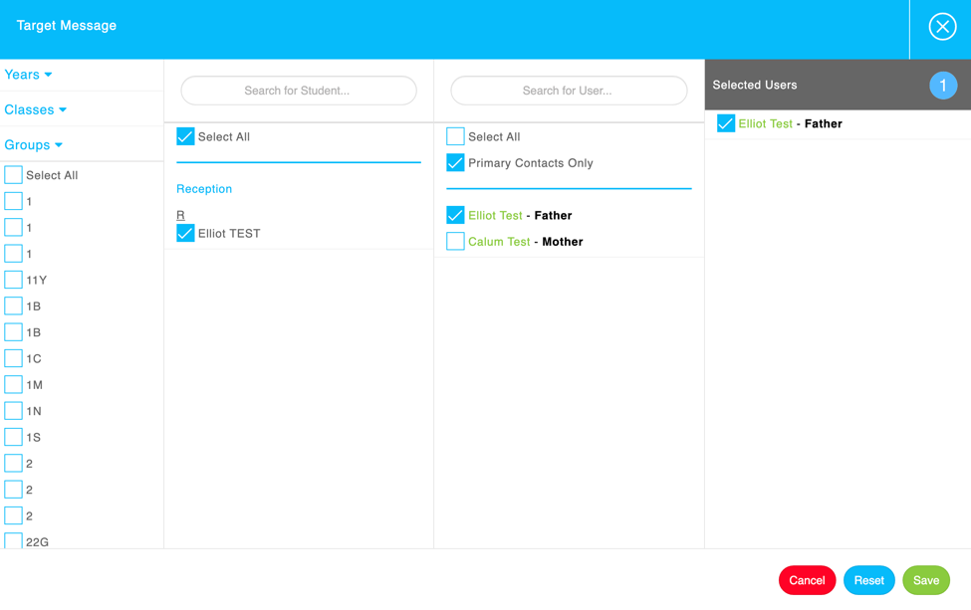

REMOVING & DEACTIVATING USERS
You can remove and deactivate users at any time from within the portal. This is actioned through the Users section. By clicking the delete icon next to the user’s name, this will remove them from the app entirely. If you only wanted to temporarily suspend their account, click on the purple dots next to their name before selecting Deactivate. You can follow these steps to Reactivate at any time.

MANAGING UPDATED CONTACT DETAILS
Parents can update their profile details using the My Profile section of their app. Whenever a parent does this, you will receive a notification within the portal, as well as an e-mail (if selected) to inform you of this change.

To view the changes, click on the Updates icon from the green menu bar in the top-right corner. The Updates button will flash to let you know if you have any new updated contact details from any users.
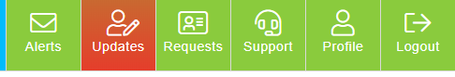

Important: Each update will override the information in our portal but does not write back into your MIS system. You can export all updates from this section to help you amend your school’s data and you can click on the glasses icon to view individually.

APPROVING ADDITIONAL CONTACTS
Parents who are listed as a priority contact 1 can invite additional users such as a partner, grandparent, carer or other family member to the app. They can do this through a tab in the more section of their app named Add Additional Contacts.

Whenever a parent does this, you will receive a notification within the app. All user requests need to be approved or declined by the school. When you approve or decline the additional contact, the record is saved so you have an audit trail. The parent who requested the contact will receive a notification to confirm the status and the new user will be added to the portal and automatically sent an invitation.

Before approval, you may wish to directly message or speak to the parent to confirm they have requested this.
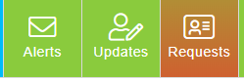
To view the requests, click on the Requests icon which will flash red to alert you.

ALERTS
Within the Parentapps Portal, there is an alert system for us to contact all our schools with any important updates and information. The Alerts button in the top-right corner will flash to let you know about any new alerts and you should also receive an e-mail.

You can read each alert by clicking on the purple read icon.

SUPPORT HUB

Our Support Hub is also located within the top of your dashboard and can be used as an aid to help you manage both the app and the portal. We have paper based and video guides on the whole system as well as useful documents for both your parents and staff. We suggest using the Support Hub as much as you can to help develop your knowledge of the system, but our support team are always on hand if you would like to speak to them.

SUPPORT
For any other advice or support regarding Parentapps Connect, please contact our office via the methods below or use our live chat through our website.

Telephone: 0151 808 0093
E-mail: support@parentapps.co.uk
Website: www.parentapps.co.uk

